Software Architecture and Design Specification
Project: Gym Management System
Version: 1.0
Authors: Team 16 (Ronak, Prajwal D, Chatresh, Nitesh, Prajwal A.)
Date: 01-10-2026
Status: Final

Revision History
Version | Date | Author | Change Summary
1.0 | 01-10-2026 | Ronak M Surana, Chatresh Ramasai Gudi | Initial draft based on SRS v1.1 and Test Plan v1.1

Approvals
Role | Name | Signature/Date
Project Manager | Ronak M Surana | 2nd October, 2026

1. Introduction
1.1 Purpose
This document specifies the software architecture and detailed design of the Gym Management System (GMS). It bridges the gap between the functional requirements outlined in the SRS and the final implementation in code.
1.2 Scope
The architecture covers the web-based MERN stack application, specifically detailing the Auth Module, Billing Module, Booking Module, and Equipment Module. It encompasses component interactions, data persistence strategies, security layers, and RESTful API designs.
1.3 Audience
This document is intended for the development team (Frontend and Backend leads), QA engineers, security auditors, and course instructors evaluating the system design.
1.4 Definitions
- MERN: MongoDB, Express.js, React, Node.js.
- RBAC: Role-Based Access Control.
- JWT: JSON Web Token.
- IDOR: Insecure Direct Object Reference.

2. Document Overview
2.1 How to use this document
This specification provides architectural deliverables including the chosen structural pattern, UML diagrams (Component and Sequence), threat models, and explicit API payload designs. Developers should reference Section 4.3 before writing route controllers.
2.2 Related Documents
- Software Requirements Specification (SRS) v1.1
- Software Test Plan (STP) v1.1

3. Architecture
3.1 Goals & Constraints
- Goals: Secure processing of user credentials, robust concurrent booking handling, and high availability (99.5% uptime).
- Constraints: Must rigidly utilize the MERN stack (Node.js LTS, MongoDB 7+). Passwords must not be stored in plaintext. Communication must strictly use HTTP/HTTPS with JSON payloads.
3.2 Stakeholders & Concerns
- Members: Data privacy, reliable class booking without accidental double-booking.
- Admin/Trainers: Accurate scheduling, secure revenue reporting, and clear equipment status.
- Developers: Modularity, clear API contracts, and maintainable codebase separation.

3.3 Component (UML) Diagram
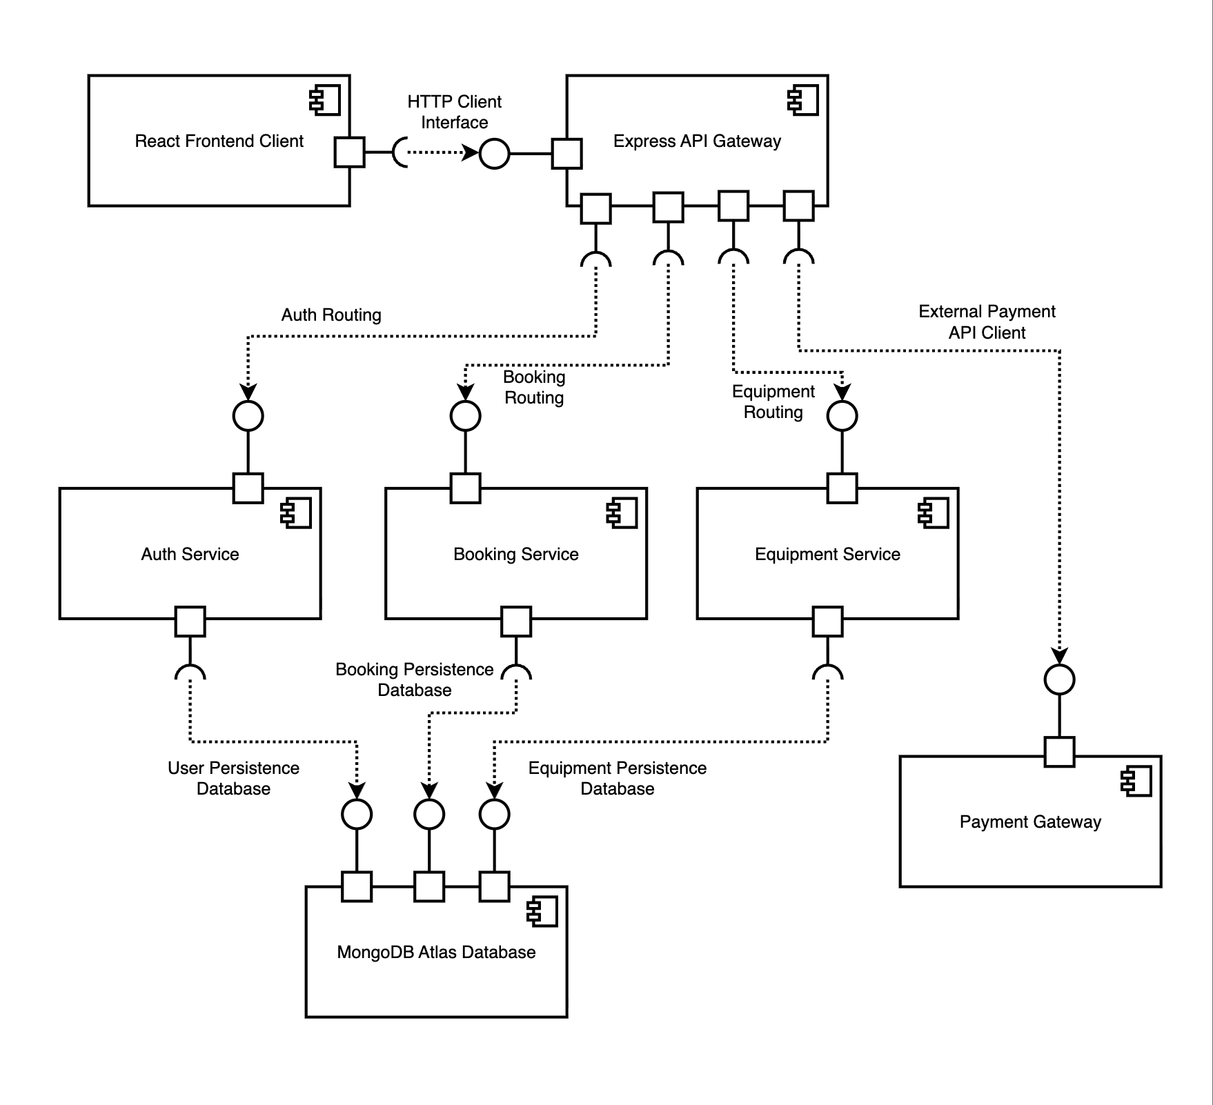
3.4 Component Descriptions
- React Frontend: A Single Page Application (SPA) built with Vite and Tailwind CSS. It manages user input, renders dynamic UI based on RBAC, and stores JWTs securely in memory.
- Express API & Middleware: Intercepts incoming HTTP requests. The authMiddleware validates JWT signatures, and the roleMiddleware enforces permissions before passing data to service controllers.
- Auth Service: Handles registration, executes bcrypt password hashing (cost factor 10+), and issues JWTs upon login.
- Booking Service: Manages class capacity checks, handles concurrency control for slot booking, and executes cancellation logic.
- Equipment Service: Tracks inventory state and logs maintenance tickets.
- MongoDB Atlas: The persistent document database storing Users, Classes, Bookings, and Equipment collections.
3.5 Chosen Architecture Pattern and Rationale
A Layered Client-Server Architecture (N-Tier) is utilized.
Rationale: This pattern separates the React presentation layer from the Express business logic layer and the MongoDB data access layer. Microservices were rejected as they introduce unnecessary network latency and deployment complexity for a standalone, single-facility gym application.
3.6 Technology Stack & Data Stores
- Frontend: React, Vite, Tailwind CSS.
- Backend: Node.js LTS, Express.js.
- Database: MongoDB 7+ (Atlas cloud cluster) via Mongoose.
- Security: Bcrypt (hashing), JWT (stateless sessions), HTTPS (transit).
3.7 Risks & Mitigations
- Risk: Booking race conditions leading to over-capacity classes when multiple users book simultaneously.
- Mitigation: The system will utilize atomic database update operations ($inc: { availableSlots: -1 }) in MongoDB combined with a query filter availableSlots: { $gt: 0 } to strictly prevent overbooking at the database level.
3.8 Traceability to Requirements
Requirement ID | Module / Component | Architecture Focus
REQ-1, REQ-2 | Auth & Billing | Secure credential storage; Webhook integration.
REQ-3, REQ-4 | Booking Service | Capacity validation; Atomic concurrent handling.
REQ-5, REQ-6 | Equipment Service | Status flagging; Data filtering logic.
REQ-SEC-01 | API Gateway | JWT validation middleware across all private routes.
REQ-SEC-02 | RBAC Middleware | Route protection based on decoded JWT role payload.
NFR-1 | Dashboard / Reporting API | API performance optimization and database indexing for < 1.5s response.
NFR-2 | MongoDB Atlas / Backup Job | Automated database snapshot scheduling and recovery procedures.
NFR-3 | Digital Entry Pass Service | High availability deployment and potential payload caching for 24/7 access.
NFR-4 | Auth Service | Integration of bcrypt library for secure, pre-storage password hashing.
NFR-5 | RBAC Middleware | Strict authorization checks applied specifically to deletion and financial route controllers.
NFR-6 | Express API Gateway | TLS configuration for forced HTTPS and strict JSON body parsing middleware.
UI-1 | React Frontend Client | Implementation of Tailwind CSS for responsive grids and a global context provider for toast alerts.
3.9 Security Architecture
Aligned with STRIDE Threat Modeling:
- Spoofing: Mitigated by enforcing JWT authentication for all state-changing actions.
- Tampering: Mitigated by validating third-party payment signatures and using Mongoose schemas to prevent NoSQL injection.
- Information Disclosure: Forced TLS 1.2+ encryption in transit; bcrypt salting/hashing at rest.
- Elevation of Privilege: Strict backend RBAC prevents Members from accessing Admin routes or modifying other users' data (preventing IDOR).

4. Design
4.1 Design Overview
The Express backend is heavily modularized. Routes define the endpoint paths, Controllers handle the business logic, and Mongoose Models define the data schemas and collection relationships.
4.2 UML Sequence Diagrams
- Diagram 1: User Registration Flow:
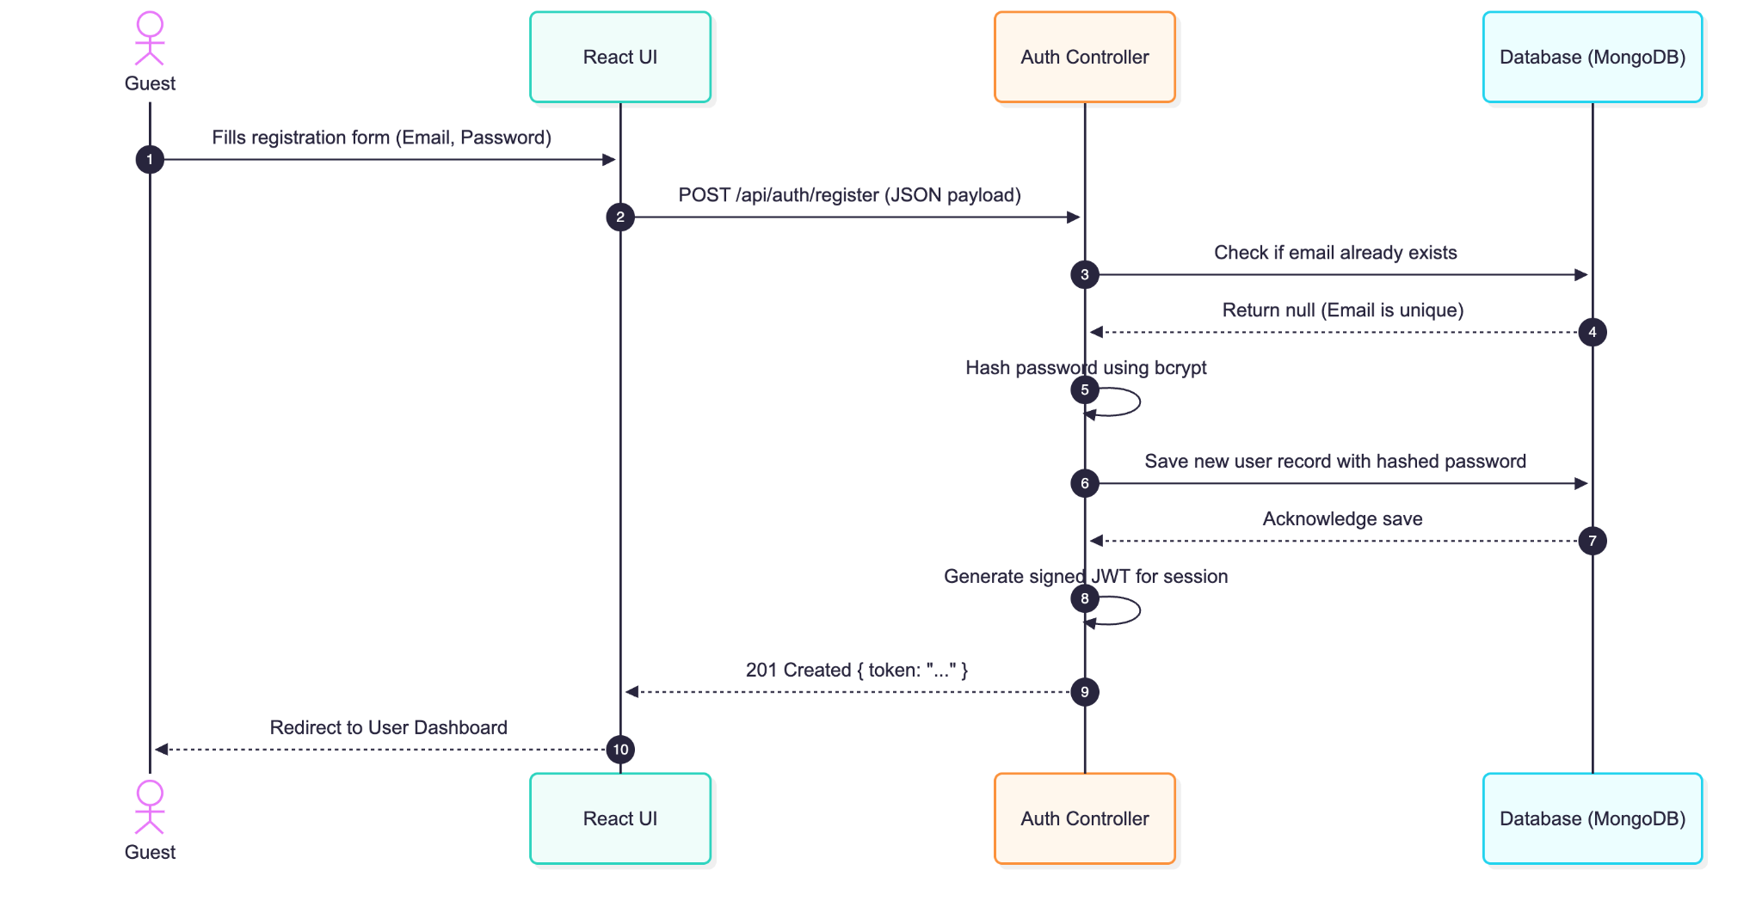
- Diagram 2: Class Booking Flow:

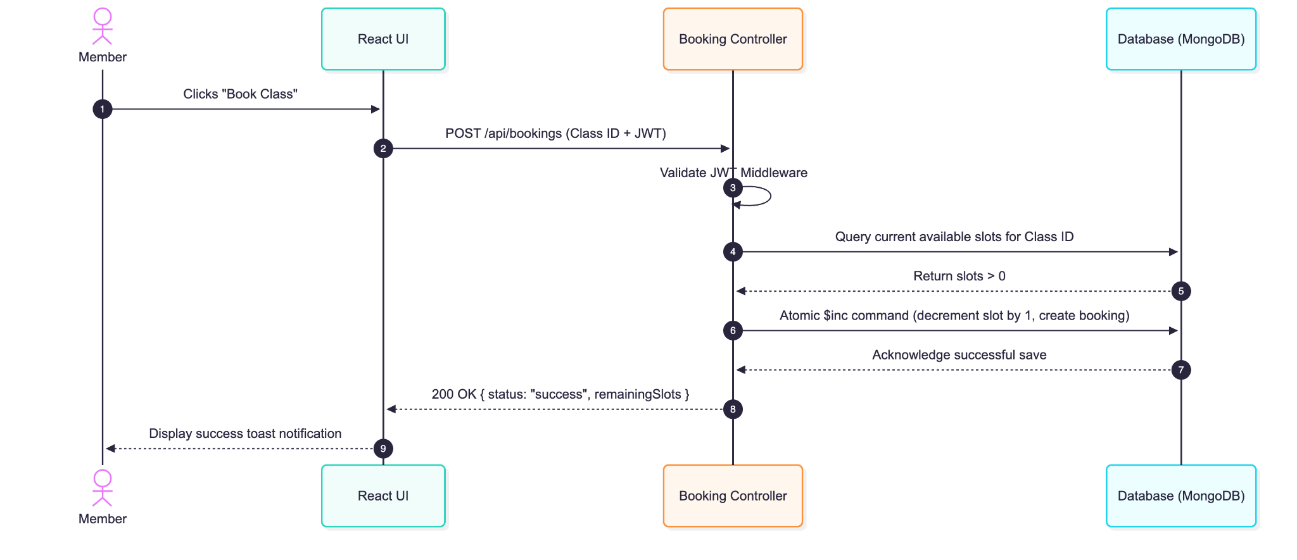

4.3 API Design
Interface 1: Class Booking Endpoint
- Endpoint: /api/bookings
- Method: POST
- Headers: Authorization: Bearer <token>
- Request Body:
{
"classId": "60d5ecb8b392d70015351a5b",
"memberId": "60d5ec49b392d70015351a5a"
}
- Success Response (200 OK):
{
"status": "success",
"bookingId": "60d5ecc4b392d70015351a5c",
"remainingSlots": 14
}
- Error Responses:
  - 400 Bad Request (Class Full)
  - 401 Unauthorized (Missing/Invalid JWT)
  - 403 Forbidden (User is not a Member)
Interface 2: Equipment Maintenance Ticket
- Endpoint: /api/equipment/ticket
- Method: POST
- Headers: Authorization: Bearer <token>
- Request Body:
{
"equipmentId": "TRD-102",
"issueDescription": "Treadmill belt slipping during use."
}
- Success Response (201 Created):
{
"status": "success",
"ticketId": "TCK-992",
"message": "Maintenance ticket logged successfully."
}
4.4 Error Handling, Logging & Monitoring
- Standardized Errors: All API errors return a consistent JSON format: { "error": true, "message": "User-friendly description", "code": HTTP_STATUS }.
- Logging: Sensitive information (plaintext passwords, full JWT strings) is explicitly stripped or masked before writing to server logs.
- Monitoring: System health is monitored via a public /api/health endpoint to verify application uptime and database connectivity.
4.5 UX Design
The React UI employs responsive layouts adapting to 375px (mobile), 768px (tablet), and 1366px (desktop) widths. Standardized toast notifications are used globally to alert users of success (green) or failure (red) states immediately after API interactions.
4.6 Open Issues & Next Steps
- Finalize the specific payment gateway provider (Stripe vs. Razorpay) to complete the webhook endpoint design.
- Determine the deployment hosting provider (e.g., Vercel for Frontend, Render/Heroku for Backend) to finalize CI/CD pipeline structures.

5. Appendices
5.1 Tools
- Diagramming: draw.io / PlantUML
- API Testing: Postman
- Frameworks: React, Express, Node.js, Mongoose

